Instructions for the preparation OF manuscripts using the Word template
Name Surname¹, Name Surname²
¹University, City, COUNTRY
² University, City, COUNTRY

*Corresponding author`s e-mail:

Abstract. The abstract should be 100–250 words (including spaces) in length (in MS Word, see the section Review/Word Count). Give a concise summary of the paper: the aim of the research, research focus, methods used, the results, and the main conclusions and recommendations. Ensure that your abstract reads well and is grammatically correct.

Keywords: Choose about 4 to 6 keywords and locate them in alphabetical order, and separate keywords with a comma.

Introduction
This document provides instructions for preparing manuscripts for publishing. The document is also a sample layout for the manuscripts submitted for publication.
The manuscripts are accepted in English. Please spell check to avoid grammatical and spelling mistakes. The submissions should be made electronically. The committee has the right to edit the submitted articles. If, due to the request of the committee.
In the introduction, the context of the research should be established, and the purpose and/or hypothesis that was investigated should be stated. Also, it is possible to include the main idea, its importance, the research's novelty and limitations, etc.

General regulations
The organisation of the body of the paper is at the author’s discretion; the only required sections are Introduction, Methods and Procedures, Results, Discussion/Conclusion, and References. The acknowledgement section is encouraged but optional.
The manuscript should be 8–15 pages long, including information about the authors, the abstract, and images. For full information about manuscript type sizes, spaces, and intervals, see Table 1.
Introduction, Conclusion, References, and Acknowledgement are not numbered.
Proper citation of sources is necessary. The publication uses a numeric citation system in the text, with a detailed list at the end of the paper. Every reference cited in the text should also be present in the reference list and vice versa. For more details, see the Reference style section.

Table 1. Type Sizes, Spaces, and Intervals
Name of style | Size (pts.) | Bold | Italic | Line spacing | Alignment | Spacing  Before | Spacing After | Small/ All Caps
Paper title | 11 | + |  | single | Centred | 0 | 0 | All Caps
Authors names | 11 | + |  | single | Centred | 12 | 0
Affiliation | 11 |  | + | single | Centred | 6 | 0
Abstract, keywords | 11 |  |  | single | Justified | 12 | 0
Section titles | 11 | + |  | single | Centred | 18 | 12 | All Caps
Subheadings | 11 |  |  | single | Left | 18 | 6
Main text | 11 |  |  | single | Justified | 0 | 0
Figure titles | 11 |  |  | single | Centred | 12 | 12
Text in figures | 10 |  |  | single |  | 0 | 0
Table titles | 11 |  |  | single | Centred | 12 | 12
Text in tables | 10 |  |  | single | Left | 2 | 2
Lists | 11 |  |  | single | Justified | 0 | 0
Equations | 11 |  |  | single | Centred | 6 | 6
Acknowledgment | 11 |  | + | single | Justified | 0 | 0
References | 10 |  |  | single | Justified | 0 | 0

Formulas and Equations
Formulas, equations, and their components presented in the text must be written in Equation Editor (e.g., Microsoft Equation, Math Type). Select the “Displayed equations” style for them. The size of basic symbols in equations should correspond to the letter size of the main text – 11 pt and formatted in Times New Roman. Place one or two tabs after the equations to put the equation’s number flush with the right margin, as in (1). Number the equations consecutively with Arabic numbers.
All numerals, including index numbers, are presented in Regular type; variables are in Italic. Punctuate equations with commas or periods when they are a part of a sentence, as in
, (1)
where a is an explanation, and b is an explanation, etc. (all symbols must be explained).

If the lists are fewer than three items, the list is generally run in paragraph form, but if the lists are at least three items long, they are arranged as follows:

where
an explanation;
b explanation;
c explanation.

Please place equations in the centre. If the equation is longer, it should be split at appropriate algebraic symbols. The parts of the longer equations must be horizontally left-aligned in the equation editor. The punctuation and numbers of longer equations, like (2), must be vertically centred with the last line of the equation.
(2)
Use the “minus sign” from the symbol list, Insert/ Symbol, for a minus sign in equations. Reformatting running text that contains special characters, such as keyboard-entered Greek letters, can cause them to disappear. To avoid this problem, always insert special characters into your document from Insert/Symbol. In the Symbol dialogue box, select the required character and click Insert. Do not employ the equation editor in the body of the text to record variables.
Use “(1)” not “Eq. (1)” or “equation (1),” except at the beginning of a sentence, for example, “Equation (1) is …”

Tables and Figures
All illustrations (line drawings and photographs) must be referred to in the text. Figures and tables should conform to the requirements outlined in Table 2. Do not use boldface for text within figures (diagrams, charts, and schemes); for emphasis, use Italic. All tables should be presented in the text and editable (do not use screenshots for figures or tables). Place figures and tables at the top or bottom of the page. Avoid placing them in the middle.

- Tables
Tables are numbered consecutively with Roman numerals and are referenced in the main text. Table captions and titles should be centred on and placed above the table. Do not abbreviate the word “Table” in the caption.
Table 2. Requirements for Tables and Figures
 | Font | Line thickness | File formats
Tables | Times New Roman 10 pt 121010 p 10 pt | 0.5 pt | *.doc, *.docx
Photos and scanned images (resolution – no less than 300 dpi) | – | – | *.tif, *png, *.jpg
Diagrams, charts, schemes | Times New Roman 10 pt | From 0.3 pt to 2 pt | *.pdf, *.eps, *.cdr, *.xls, *.xlsx, *.dwg
Note: The width of figures and tables should not exceed the width of paragraph text.

- Figures

Number the figures consecutively with Arabic numerals. Figure captions should be placed below the figures and justified. One-line figure captions may be centred.

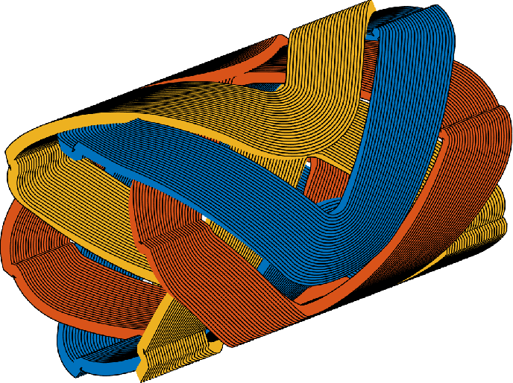
Fig. 1. 3-phase 6-coil slotless winding used as a basis.

Reference Style

General Principles
- The publication uses a numbered citation style.

- References must be cited in numerical order according to their first appearance in the text and indicated using Arabic numerals in square brackets.

- Example in text:
  - Renewable hydrogen systems are increasingly studied in Northern Europe [1].
  - Several studies have evaluated PV–electrolyser integration [2,3].

- If multiple references are cited together, they should be separated by commas or presented as a range.

- Examples:
  - [4,5,7]
  - [8–10]

Reference List

- All references cited in the manuscript must appear in the reference list at the end of the paper, arranged numerically in the order of citation.

- Authors’ names should be written as: Surname, name initial (-s)

- Journal titles should be written in full (not abbreviated) and italicised.

Reference Formatting Examples

- Journal Articles

Author, A.A.; Author, B.B.; Author, C.C. Title of the article. Journal Title Year, Volume, Page range. DOI

- Books

Author, A.A. Book Title; Publisher: City, Country, Year.

- Book Chapters

Author, A.A. Title of chapter. In Book Title; Editor, A.A., Ed.; Publisher: City, Country, Year; pp. xx–xx.

- Conference Papers

Author, A.A.; Author, B.B. Title of paper. In Proceedings of the Conference Name, City, Country, Date; Publisher: City, Country, Year; pp. xx–xx.

- Websites

Author/Organisation. Title of webpage. Available online: URL (accessed on Day Month Year).

- Reports and Institutional Publications

Organization. Title of Report; Publisher: City, Country, Year.

- Additional Formatting Rules

- All references must be complete and accurate.
- DOIs are strongly recommended for journal articles where available.
- References should be formatted using consistent punctuation and spacing.
- Authors should ensure that every reference cited in the text appears in the reference list and vice versa.
- Use the transliterated (not translated) version of the names and sources in Cyrillic.
- For papers published in journals available in two or more languages, please give the English citation first, followed by the original language citation.
- Please do not use automatic endnotes in Word.

CONCLUSION

Conclusions or generalisations of the research should be presented using Times New Roman 11 pt. Bullet-point arrangement is strongly preferred.

Acknowledgment
People who contributed to the work should be listed in the acknowledgements, along with their contributions. You must ensure that anyone named in the acknowledgements agrees to being named. Please avoid identifying any of the authors before peer review!
For example, this work has been supported by the European Social Fund within the project “Development of multifunctional nanocoatings for aviation and space techniques constructive parts protection” No. 2013/0013/1DP/1.1.1.2.0/13/APIA/VIAA/027

References
- Zhang, Y.; Wang, J.; Chen, H. Performance analysis of photovoltaic systems under varying climatic conditions. Energy Conversion and Management 2020, 214, 112897. https://doi.org/10.1016/j.enconman.2020.112897
- Carmo, M.; Fritz, D.L.; Mergel, J.; Stolten, D. A comprehensive review on PEM water electrolysis. International Journal of Hydrogen Energy 2013, 38, 4901–4934. https://doi.org/10.1016/j.ijhydene.2013.01.151
- Kalogirou, S. Solar Energy Engineering: Processes and Systems, 2nd ed.; Academic Press: London, UK, 2014.
- International Energy Agency. Renewables 2023: Analysis and Forecast to 2028; IEA: Paris, France, 2023.
- Turner, J.; Sverdrup, G.; Mann, M.K.; Maness, P.; Kroposki, B.; Ghirardi, M.; Evans, R.; Blake, D. Renewable hydrogen production. International Journal of Energy Research 2008, 32, 379–407. https://doi.org/10.1002/er.1372
- Lund, H.; Østergaard, P.A.; Connolly, D.; Mathiesen, B.V. Smart energy systems for coherent 100% renewable energy and transport solutions. Applied Energy 2017, 145, 139–154. https://doi.org/10.1016/j.apenergy.2015.01.075
- European Commission. Hydrogen Strategy for a Climate-Neutral Europe; European Commission: Brussels, Belgium, 2020.
- U.S. Department of Energy. Hydrogen Production: Electrolysis. Available online: https://www.energy.gov/eere/fuelcells/hydrogen-production-electrolysis (accessed on 20 January 2026).
- IRENA. Green Hydrogen Cost Reduction: Scaling Up Electrolysers to Meet the 1.5°C Climate Goal; International Renewable Energy Agency: Abu Dhabi, UAE, 2020.

